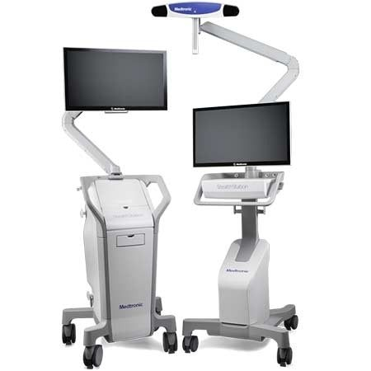 HEALTHCARE PROFESSIONALS

StealthStation S8 Surgical Navigation System

Neurosurgery and Spine Procedures

## **OVERVIEW**

### **INTUITIVE. PROVEN. SIMPLE AND FAST**

The StealthStation™ S8 surgical navigation system enables you to precisely track the location of surgical instruments throughout a procedure. The StealthStation S8 system introduces the most advanced version of Stealth technology — a combination of hardware, software, tracking algorithms, image data merging, and specialized instruments to help guide you during surgical procedures.

## **INDICATIONS**

The StealthStation System is intended as an aid for precisely locating anatomical structures in either open or percutaneous procedures. The StealthStation System is indicated for any medical conditions in which the use of stereotactic surgery may be appropriate, and where reference to a rigid anatomical structure, such as the skull, a long bone, or vertebra, can be identified relative to a CT or MR based model, fluoroscopy images, or digitized landmarks of the anatomy.

## **PRODUCT DETAILS**

The StealthStation surgical navigation system offers both optical and EM tracking capabilities, integration with external devices like microscopes and ultrasound, a broad array of instrument offerings, and core software applications for neurosurgery and spine procedures including:

* Biopsy
* Tumor resection
* Catheter placement
* Deep brain stimulation lead placement
* Spine decompression or fusion (including, but not limited to ACDF, ALIF PLIF, TLIF, cortical screw placement)
* Spinal or pelvic fixation (including, but not limited to, SI fixation, placement of occipital pedicle, cortical, facet screws, fixation for scoliosis, kyphosis, or other deformity )
* Treatment for spinal or sacral trauma (including, but not limited to, vertebroplasty, sacroplasty )

### **SYSTEM ADVANCEMENTS**

* Intuitive user interface with two touchscreen monitors, which support multitouch gestures like pinch-and-zoom and drag-and-drop1
* Better visualization with easier manipulation of 2-D and 3-D views and intuitive layering and blending tools2
* Patient registration with more versatility, such as using both touch and trace techniques within the same registration process2
* Model building tools to get more out of the data and improve your planning process
* Single or dual cart configurations for greater flexibility3

### **CAPABILITIES**

* Interfaces with intraoperative imaging systems, including iMRI , iCT , C-arms, and the O-arm™ surgical imaging system, to orient surgeons with 3-D images of the patient’s anatomy
* Tracks surgical instruments in real time, based on preoperative and intraoperative images
* Relays movements of instrumentation relative to patient anatomy via optical or electromagnetic navigation options
* Helps guide your planning and approach prior to and during surgery, allowing you to create, store, and simulate progression along one or more surgical trajectories
* Integrates with external devices like endoscopes and microscopes, streamlining visualization workflows

### **SYSTEM TECHNOLOGIES**

**Dual Cart Stealth S8 System Design**  
Interact with the StealthStation surgical navigation system through two large, 27-inch, high-definition, touchscreen monitors, providing ultimate flexibility in interacting with the system.

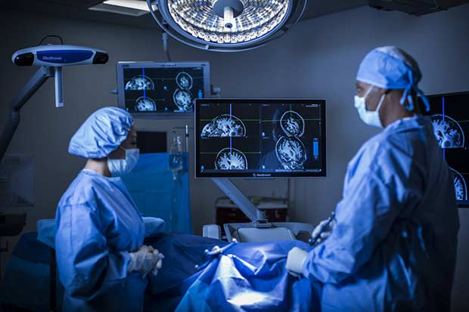

* Two electromagnetic emitter designs, each with large tracking volume
* 1 terabyte solid-state drive — ample space to store examinations of patients
* 16GB of RAM memory for fast performance and image manipulation
* Optical camera with large tracking volume provides flexibility in positioning and addressing line-of-sight issues

### **STREAMLINED WORKFLOWS IN THE OR**

**Touchscreen Interface of StealthStation S8**

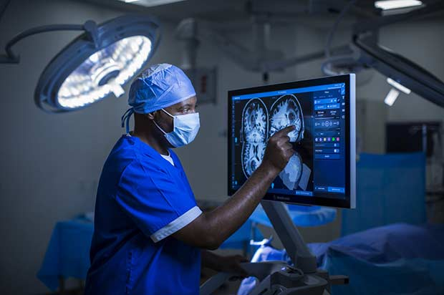

### **CONNECTIVITY**

* Wireless connectivity to hospital and medical devices, allowing the import and export of exams from virtually anywhere within the hospital network
* Automatic patient registration with the O-arm(opens new window) imaging system
* Operating system adapts to any 16:9 aspect ratio, with resolutions up to full HD 1920 x 1080 and display on multiple screens in the OR
* Digital and analog output, allowing integration

### **CYBERSECURITY**

Each customer can define the level of security for user authentication, antivirus protection, encryption, and firewall protection.